1. We can start the jupyter notebook at any folder by only opening that folder in the cmd and in it we have to write the following command:

Jupter notebook

1. And than when the notebook will open in the browser, the link will have in the format of the localhost, and than make remove the /tree after the localhost statement, and than write the **/lab** in the url as shown below to start the notebook in form of the jupyter lab:

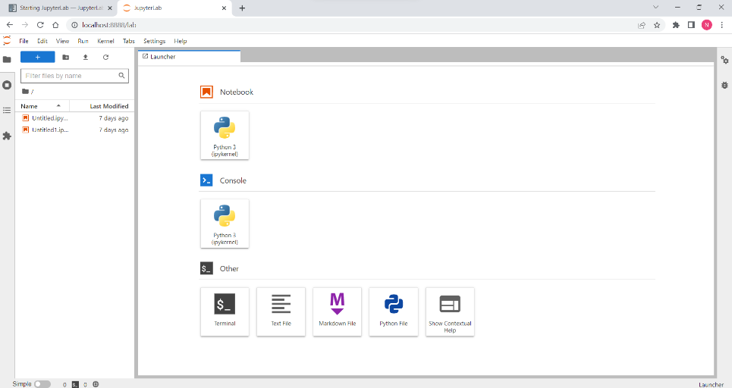

🡪Before doing this we have installed the juypter lab by help of the coda which we have already installed, The statement used for the installation of the juypter lab is as shown below:

**conda install -c conda-forge jupyterlab**